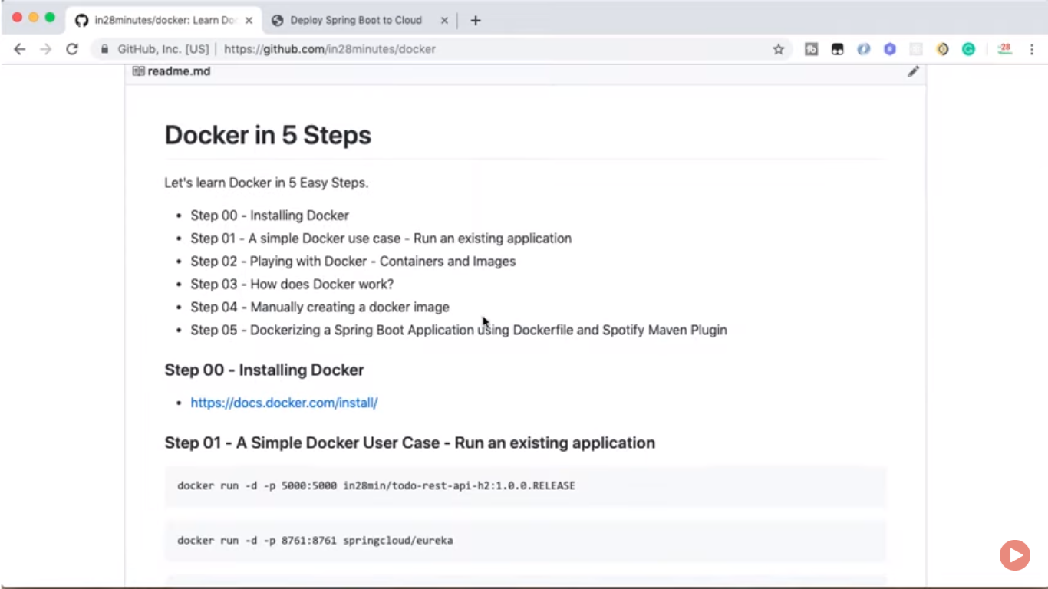

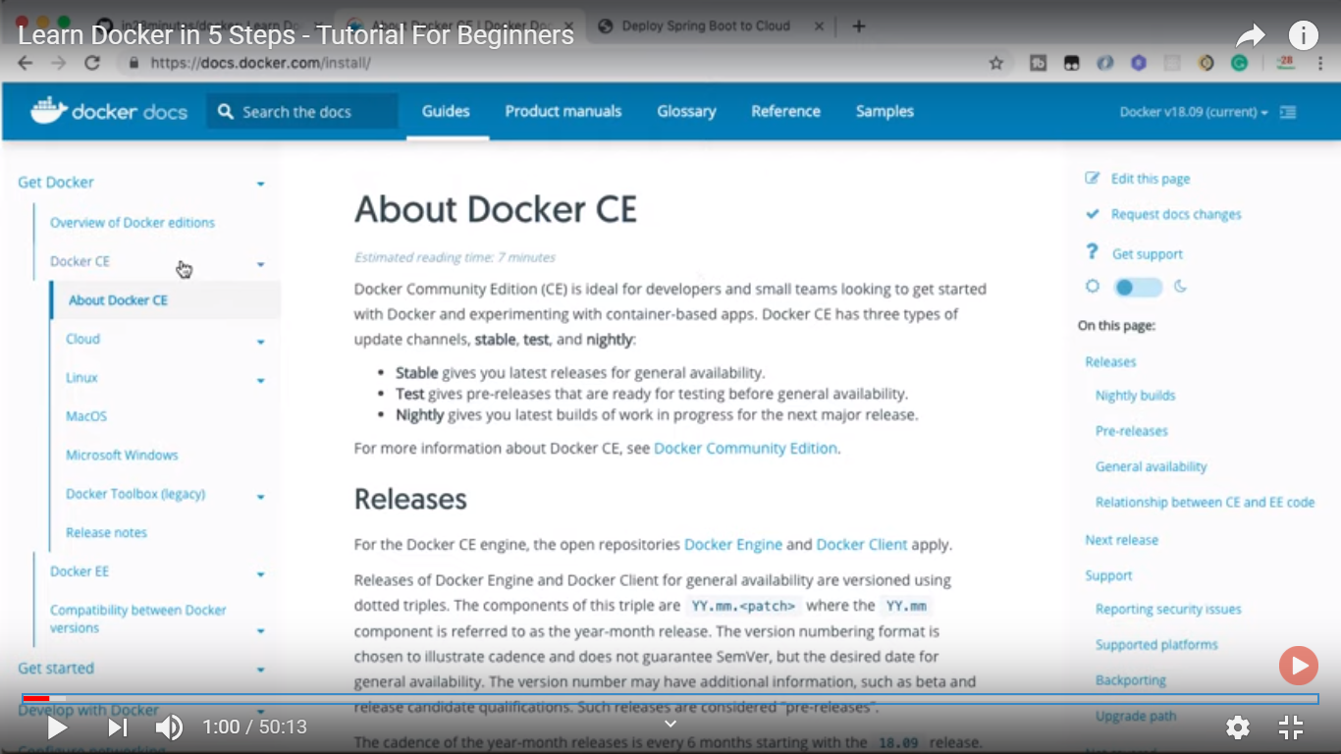

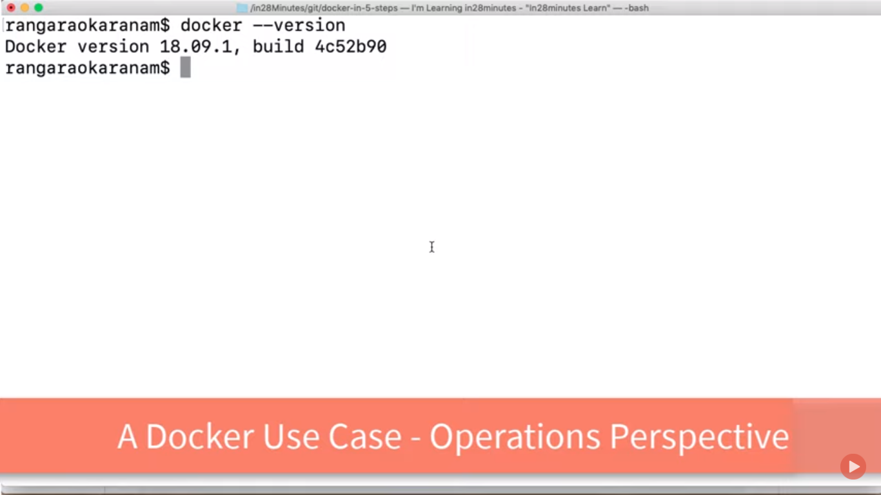

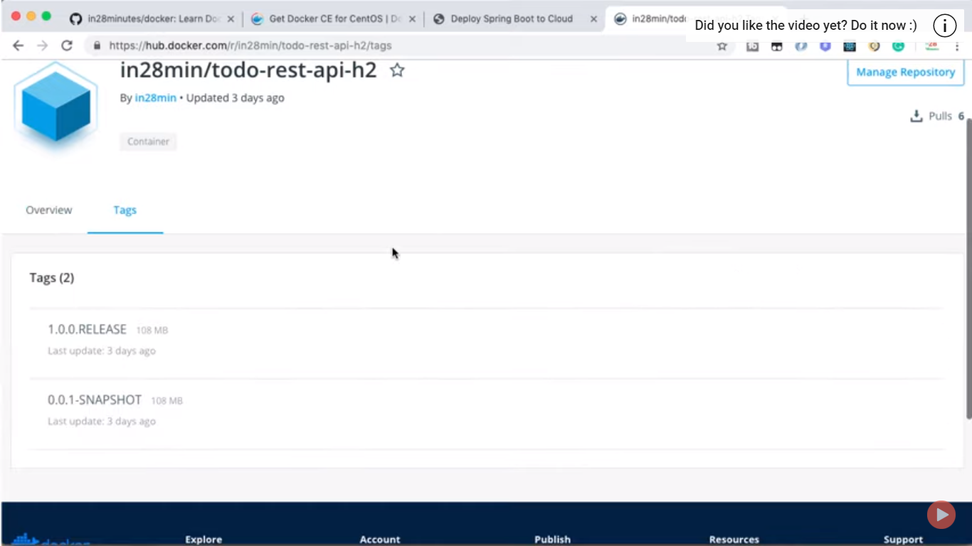

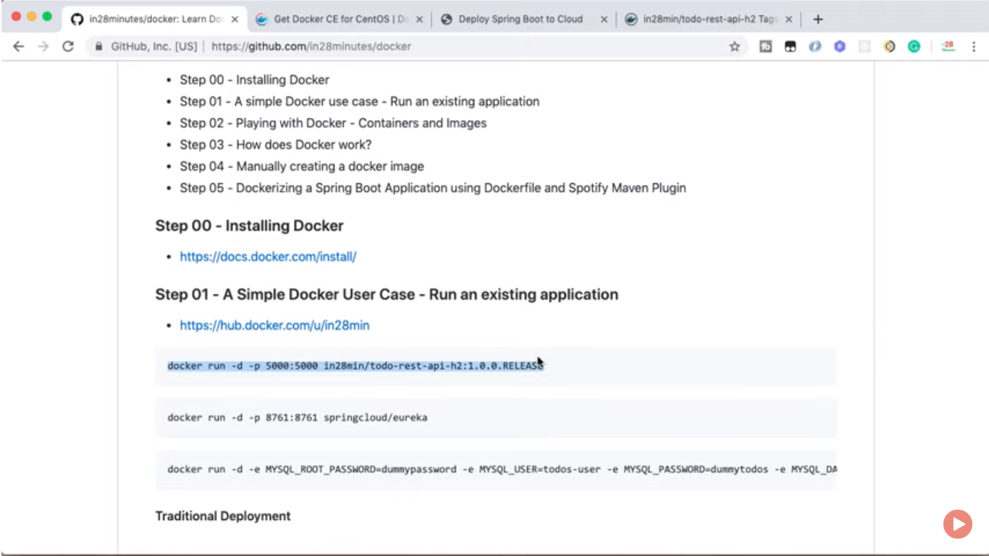

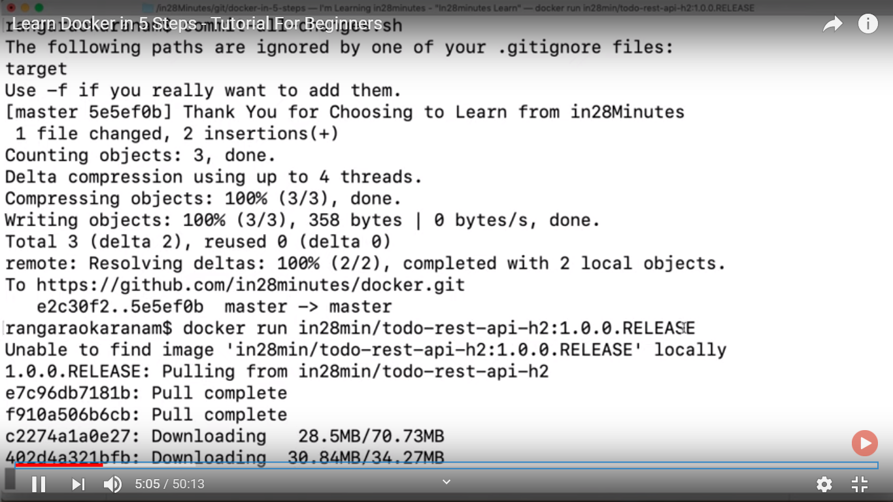

For exposing port:: container:localhost

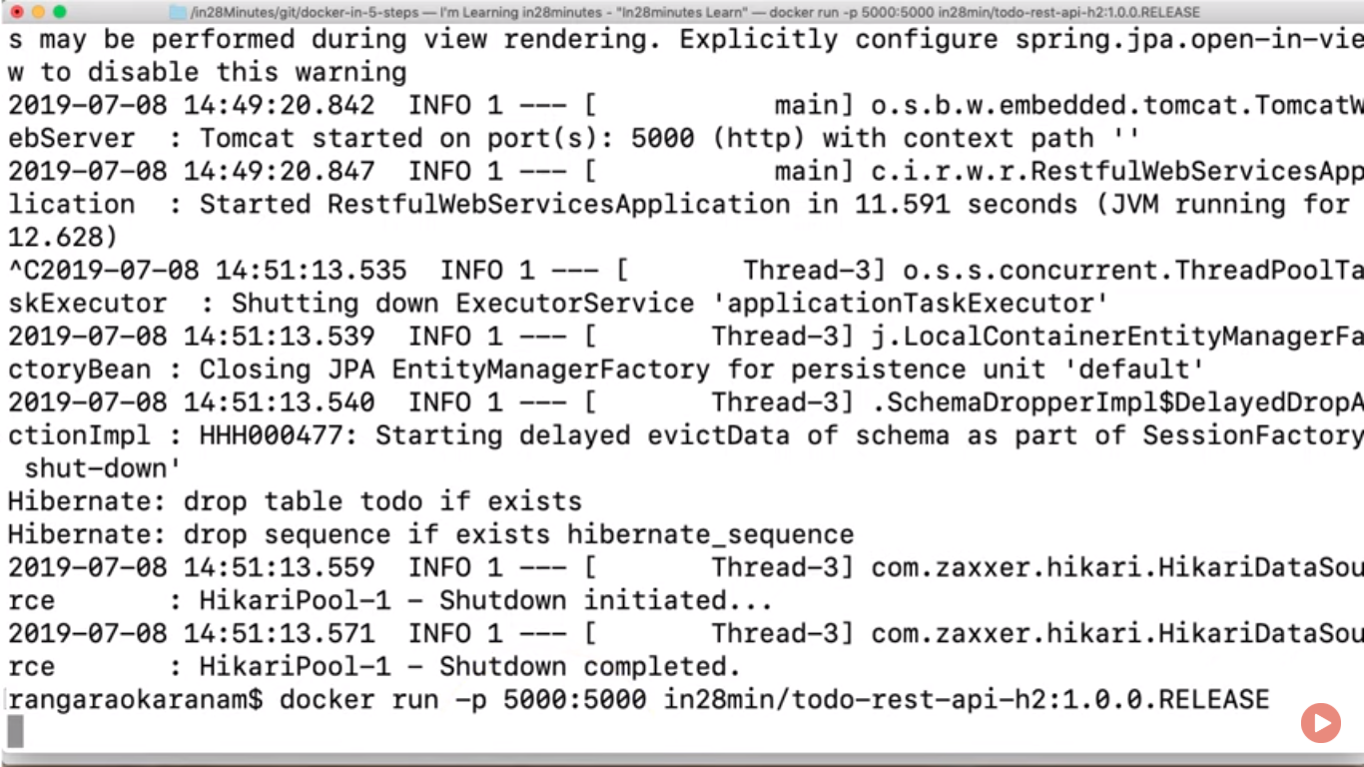

Traditional env::

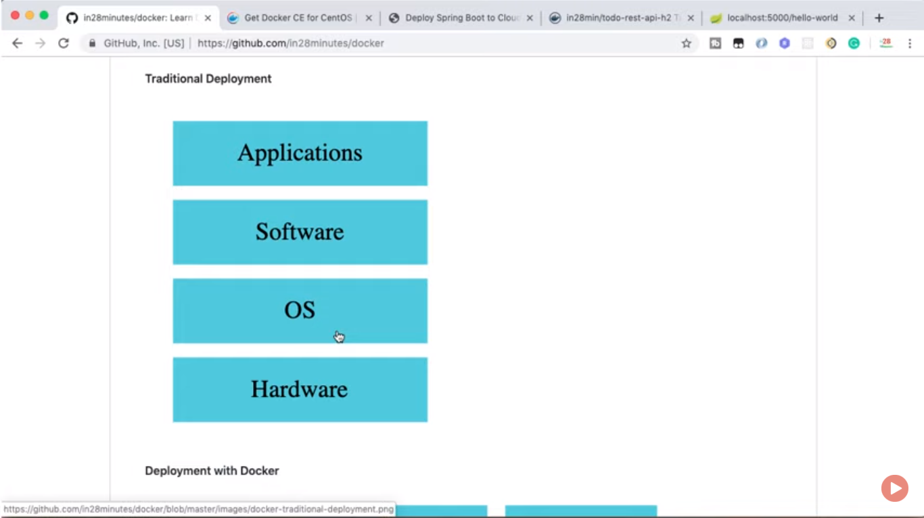

Docker architecture::

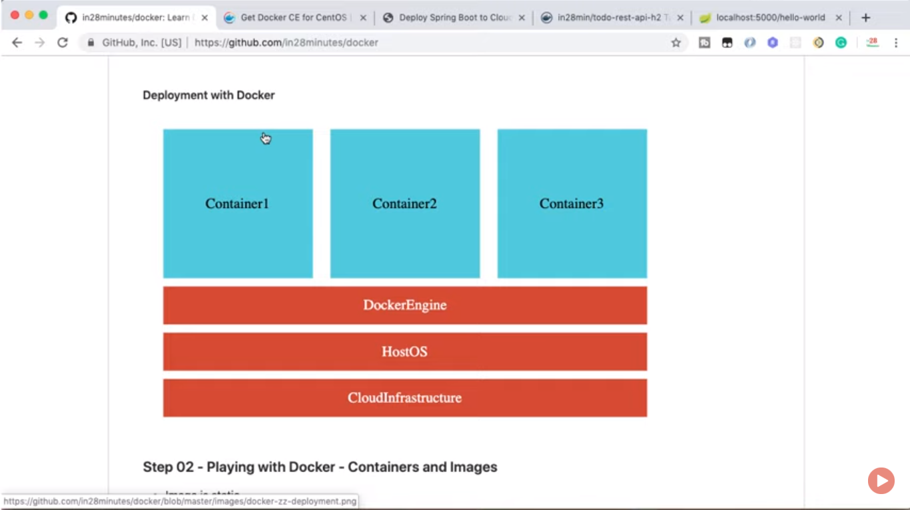

For discovery of clients::

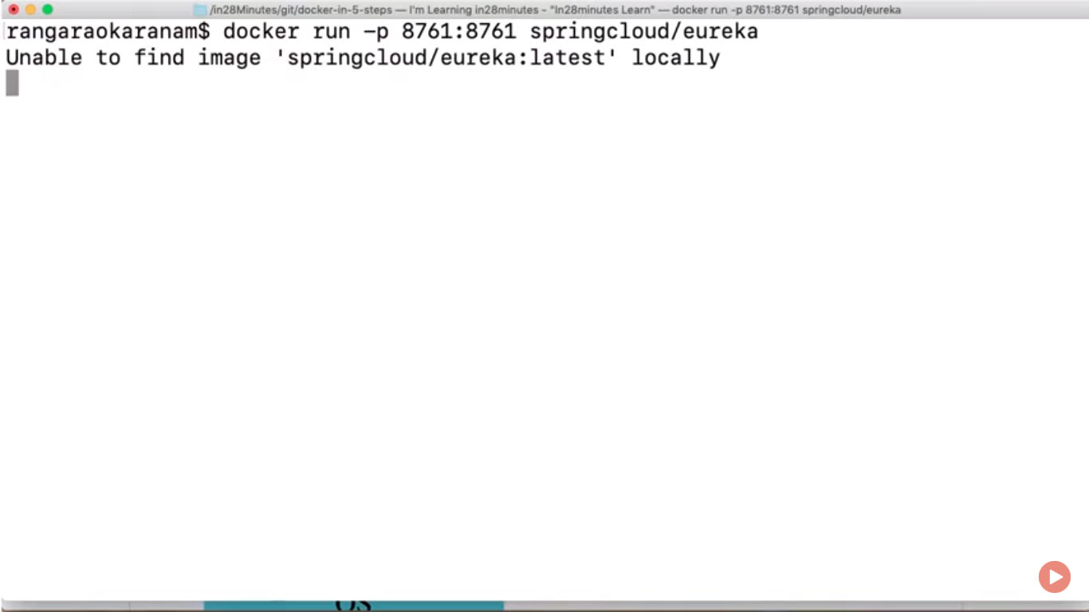

Launching up in detach mode so that it cannt be stop using Ctrl+c,it associate Container id as a big no.

Without log traces.

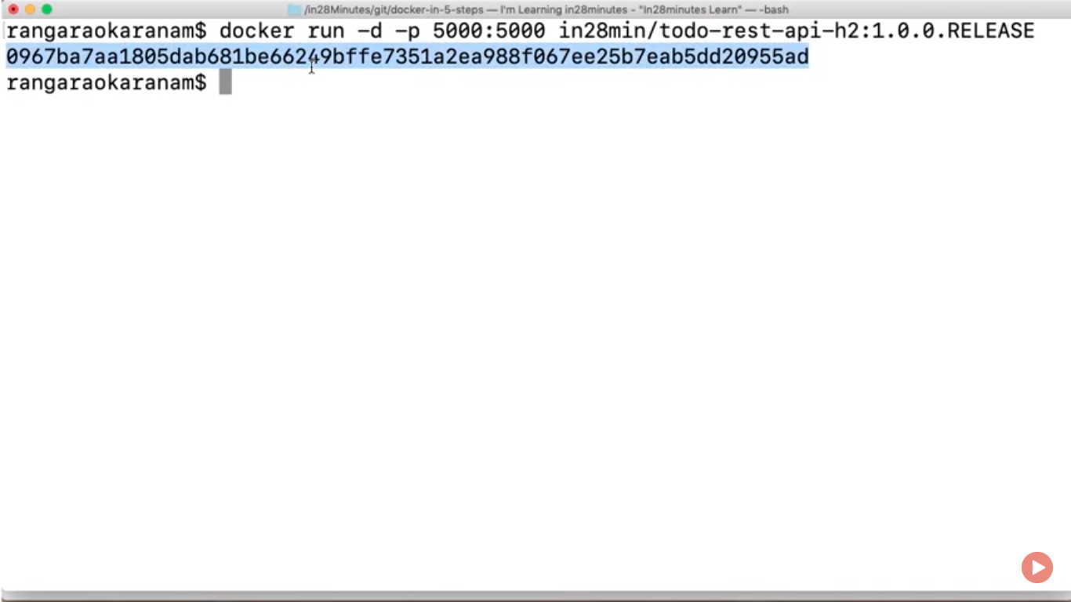

Docker is based on virtualization it remove guest os functionality.

More::

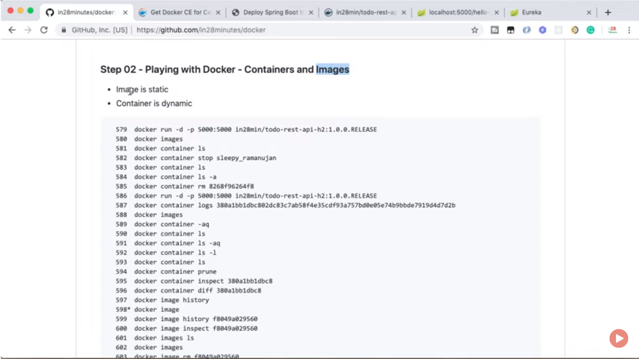

For checking docker images downloaded in local machine::  
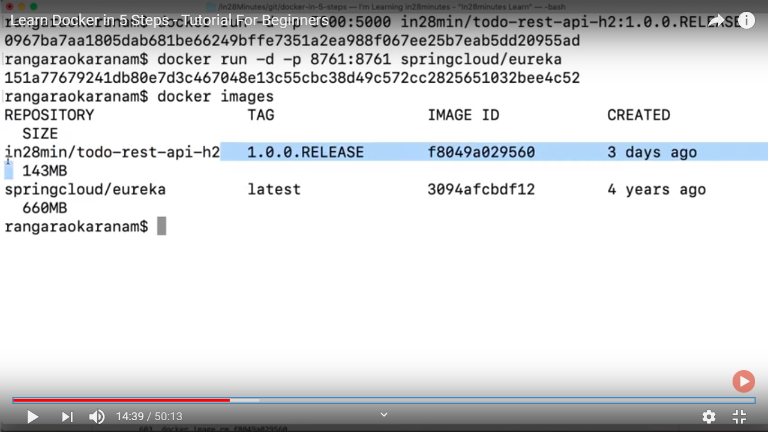

Containers:: these what are created when you running images with certain port and configuration.

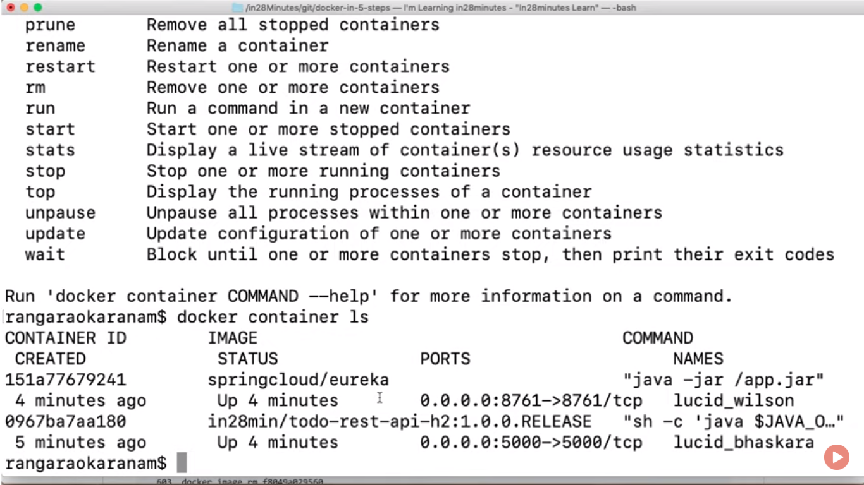

Container is running version of images

Images are static

ls –a is used for all containers

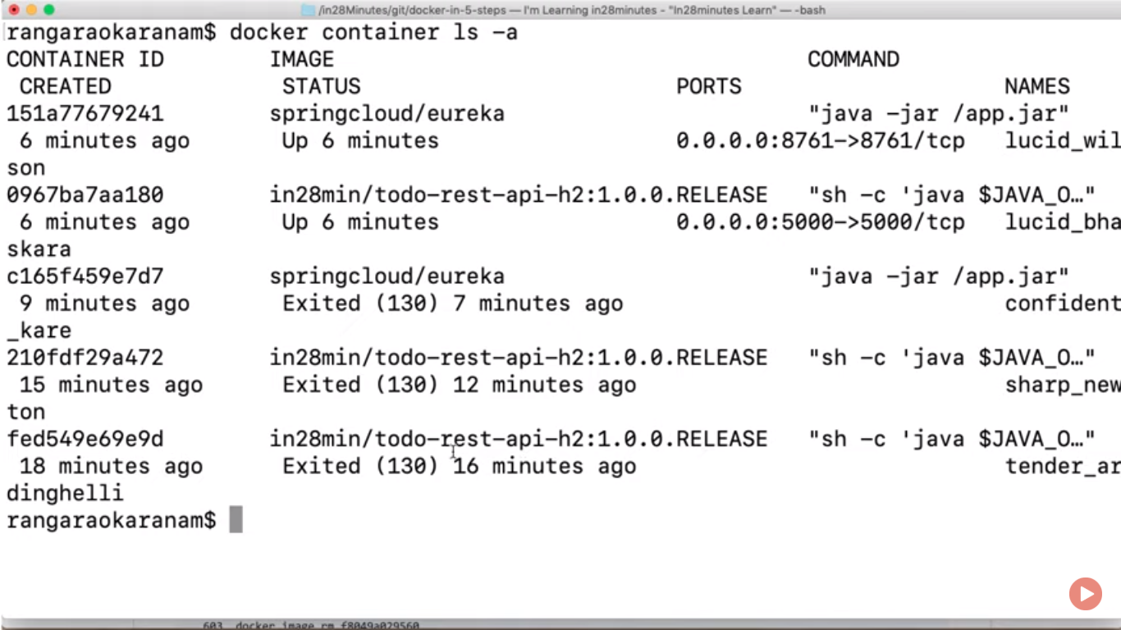

Its failed due to port is already in use.

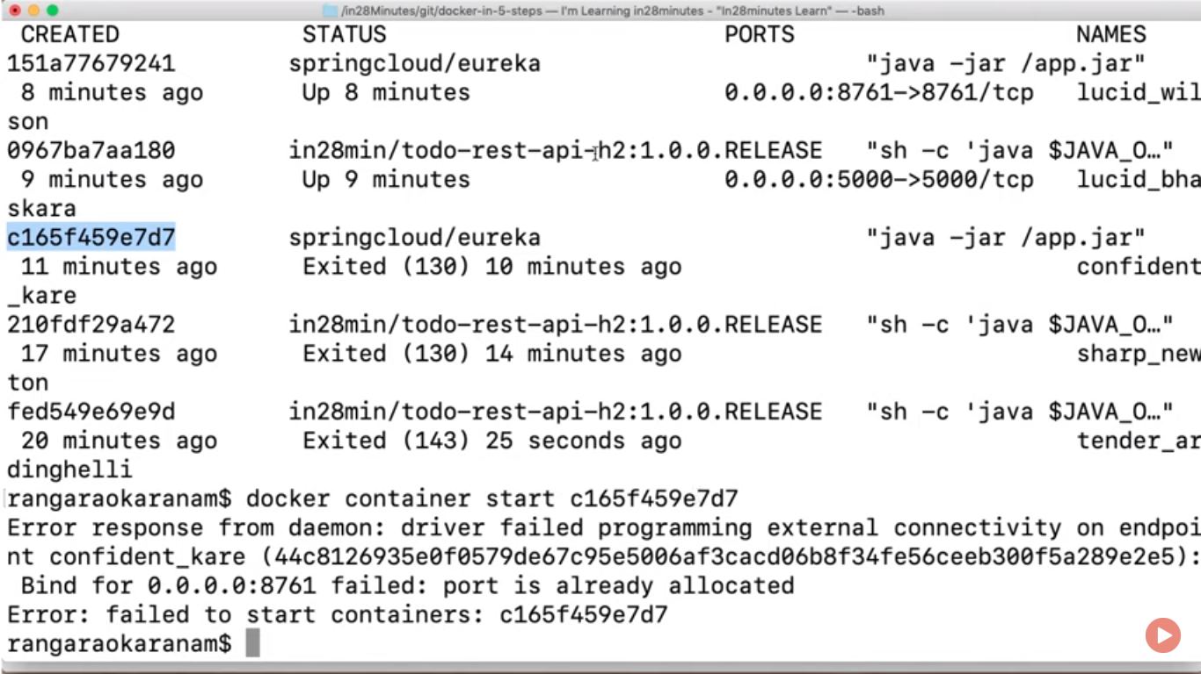

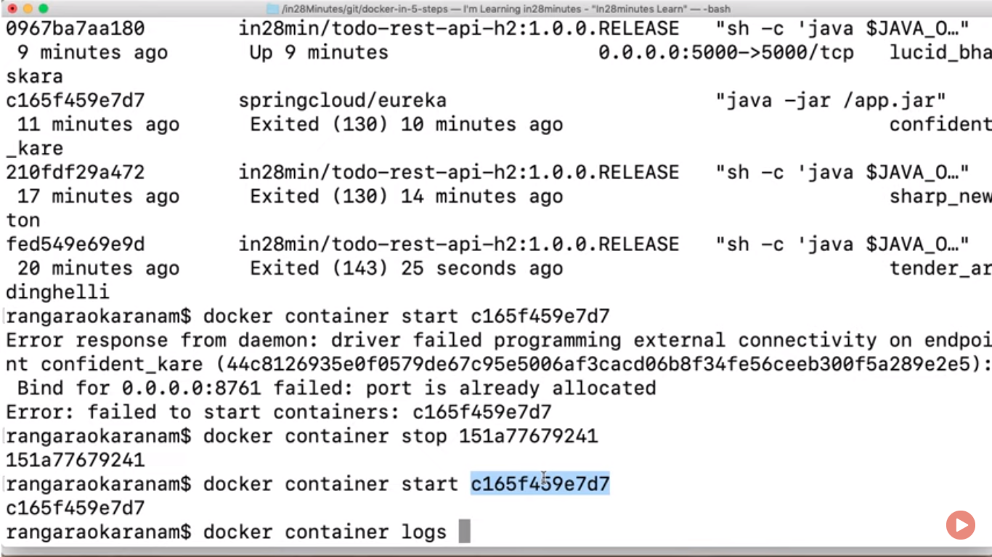

Remove containers::

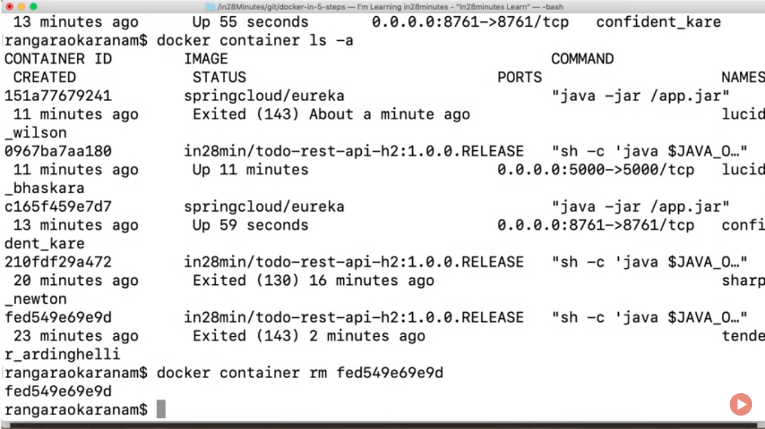

How does docker works:

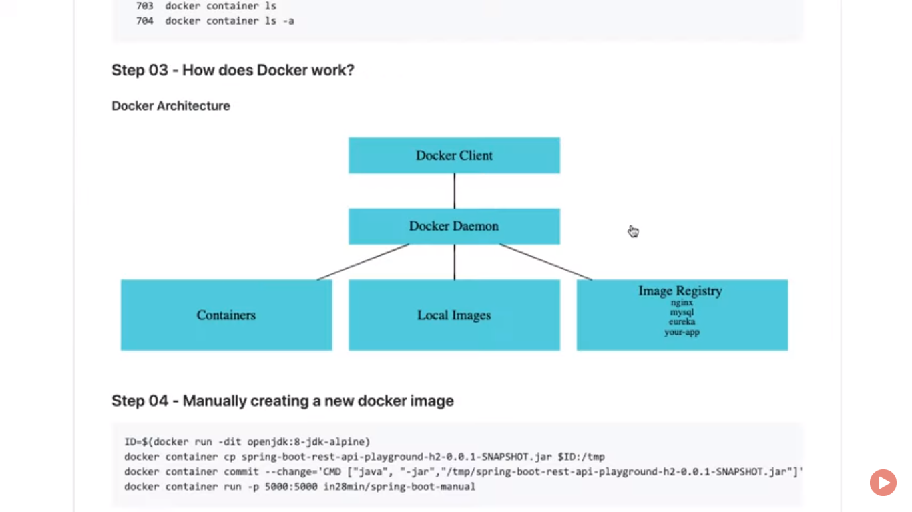

When working with docker then required 2 things running in our machine docker client and docker daemon. Its like client server side architecture. Client exe. Commands agains docker deamon.

Default docker hub repos is image registry if images is not found in locally.

running application using eclipse runas ->maven build->then provide goals as package

then it run all test cases and create jars.

For building an image first configure docker: there is it in commands basically used for interective mode. Java alpine 8 is smaller unit of java.18 version. d for detach mode

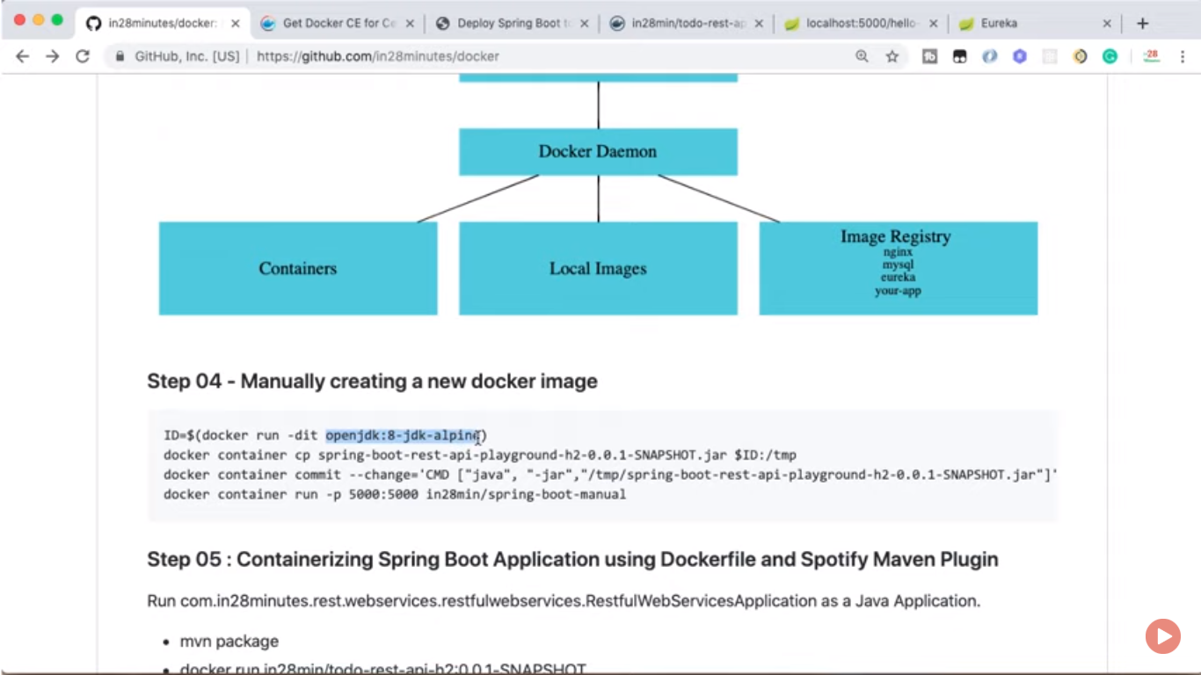

Coping jar to specific containers:

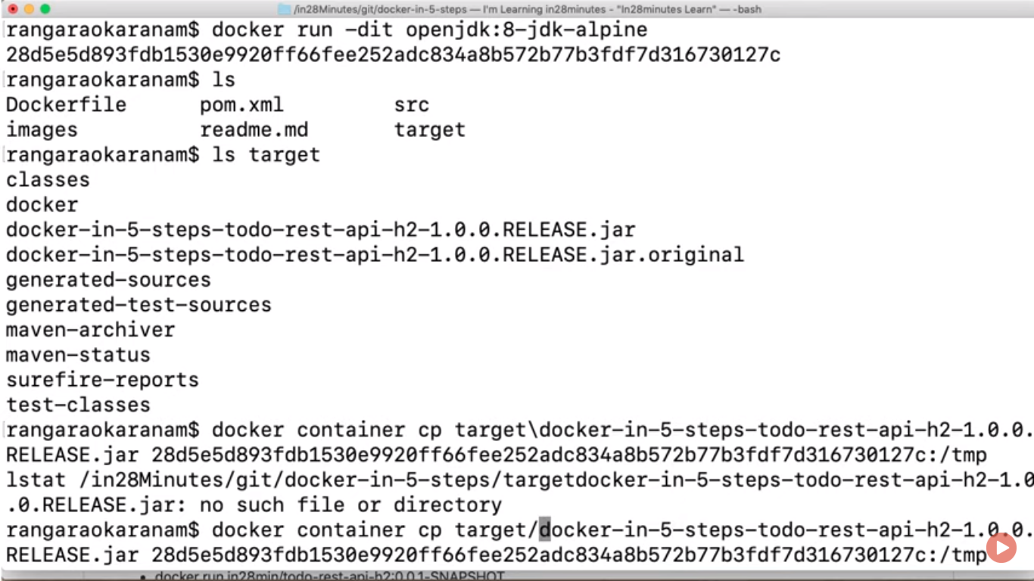

For checking is image successfully copied on it or not

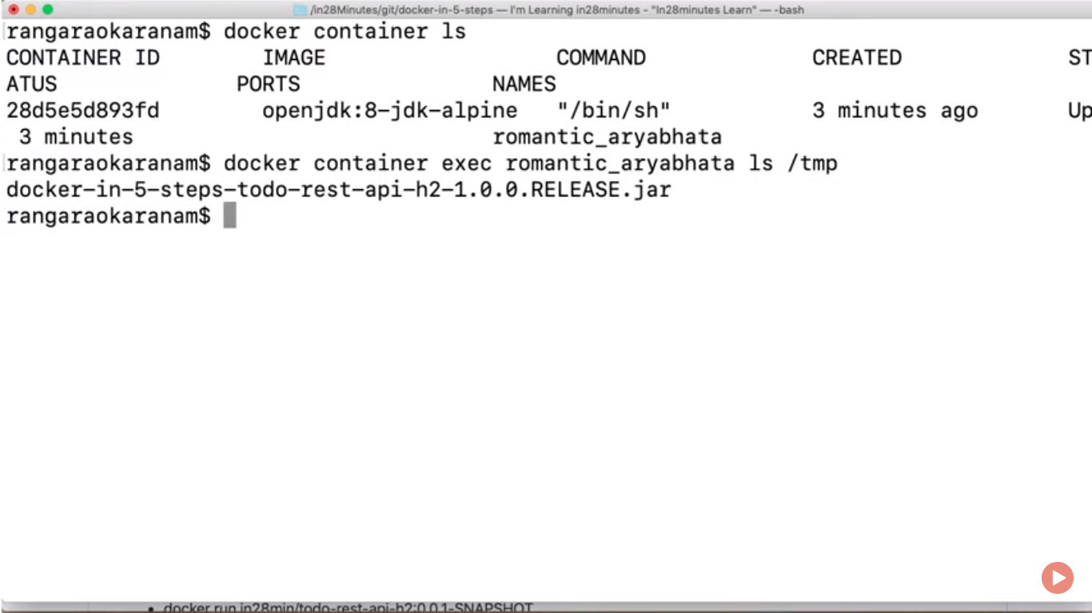

Create image inside docker on top of container:

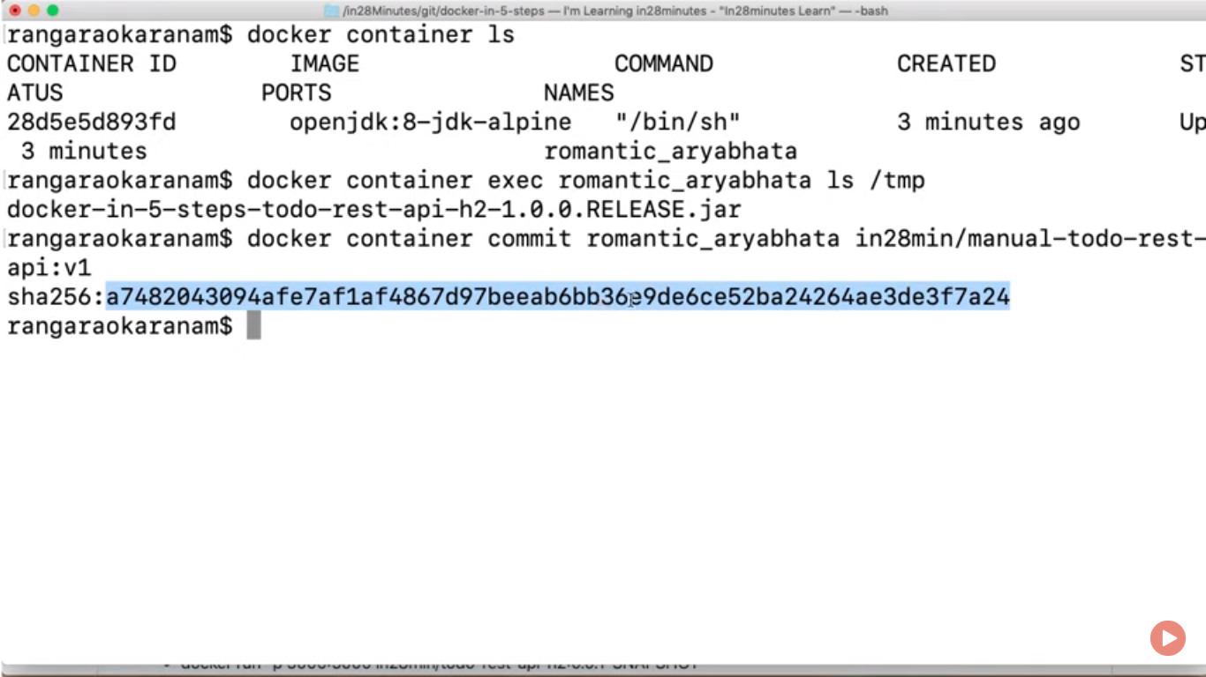

Comiting v2 version in docker and launch jar:

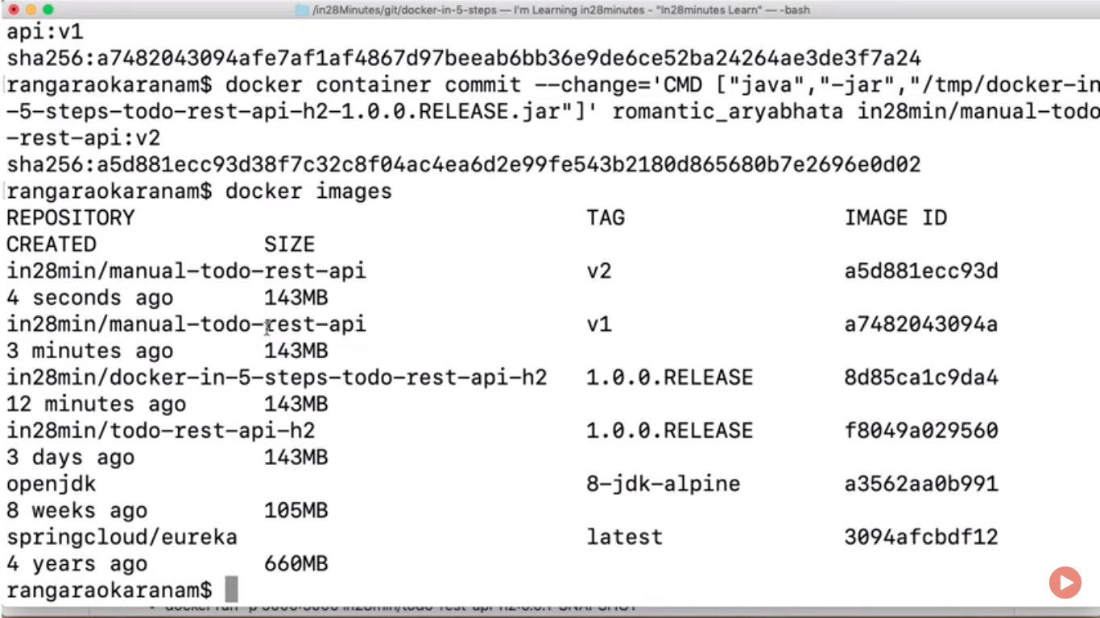

Now usages of docker file and plugin for removing this tedious picture::

For searching for mature version::

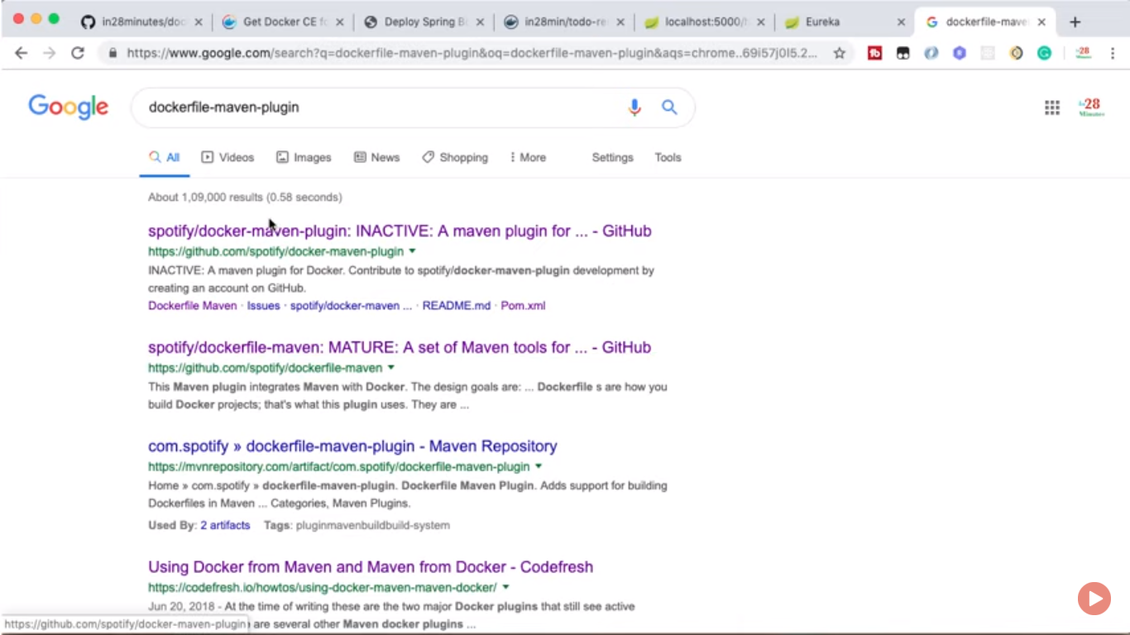

Inside code::  
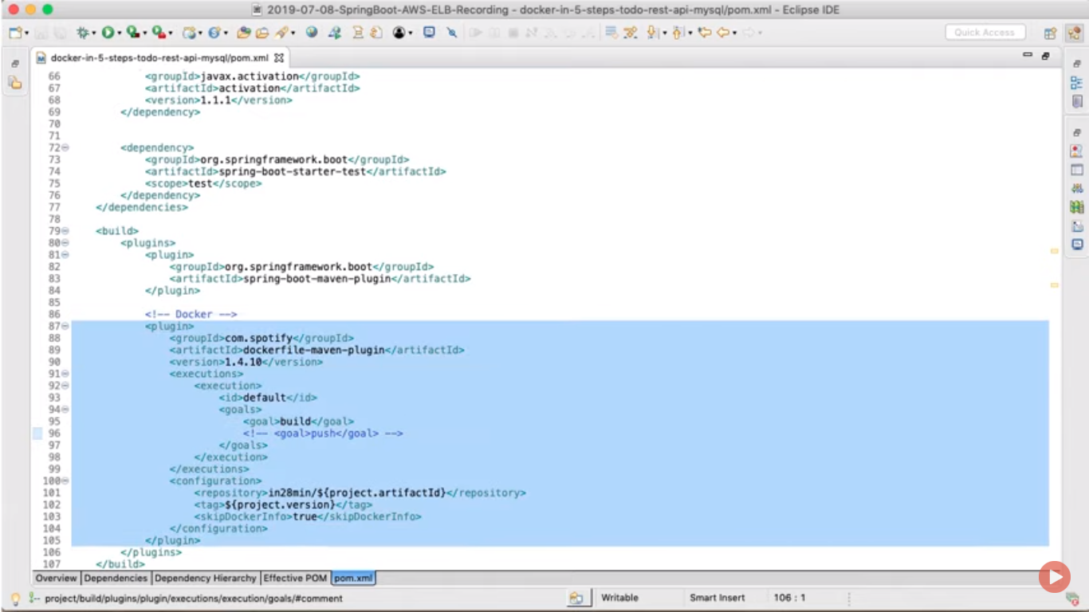

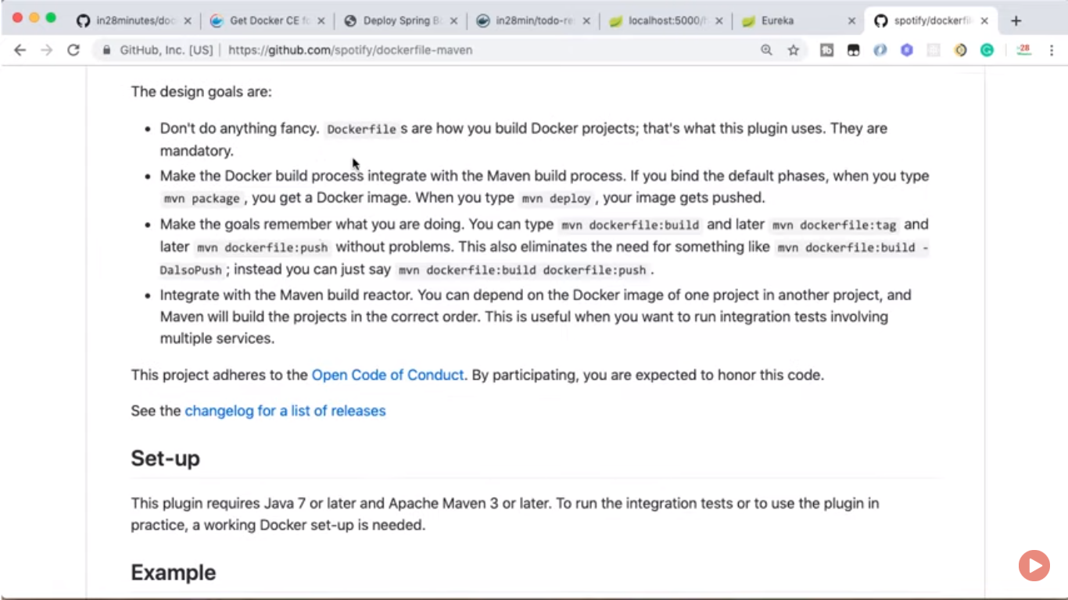

Docker file also present in project with D(caps D)

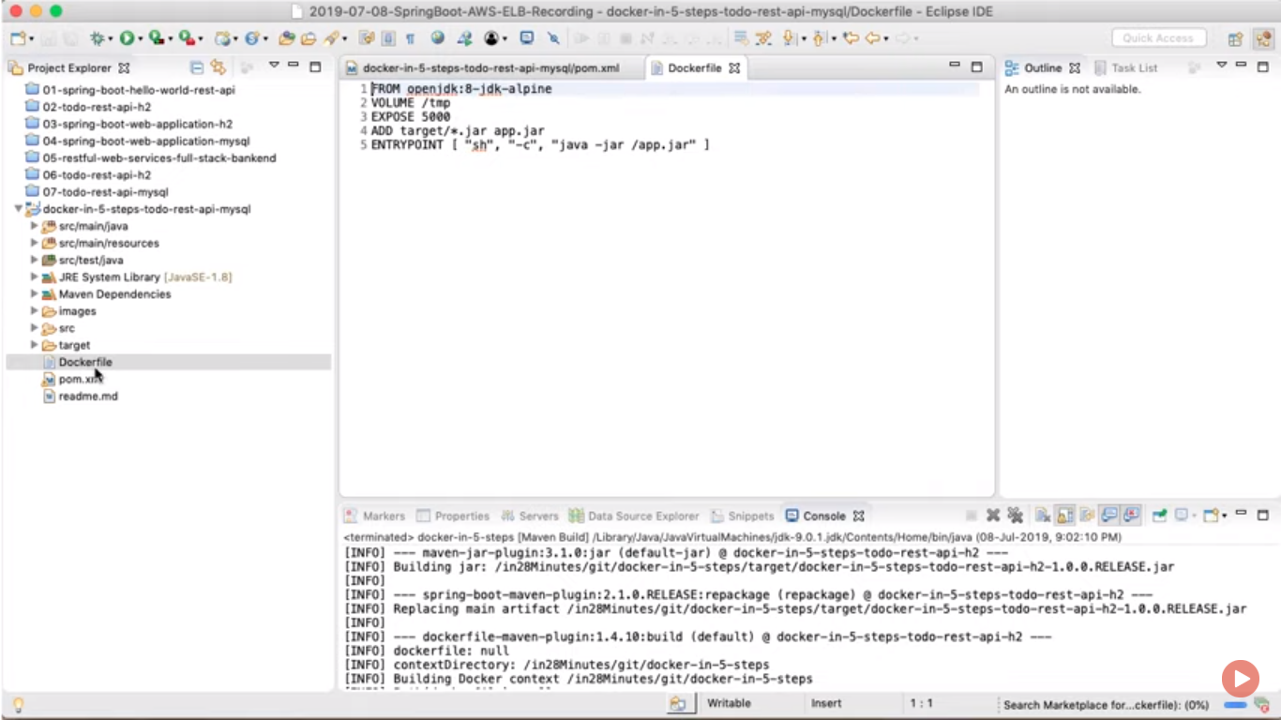

Add is like copy command for adding as a add.jar in current

What should be launch when running container is in entrypoint.

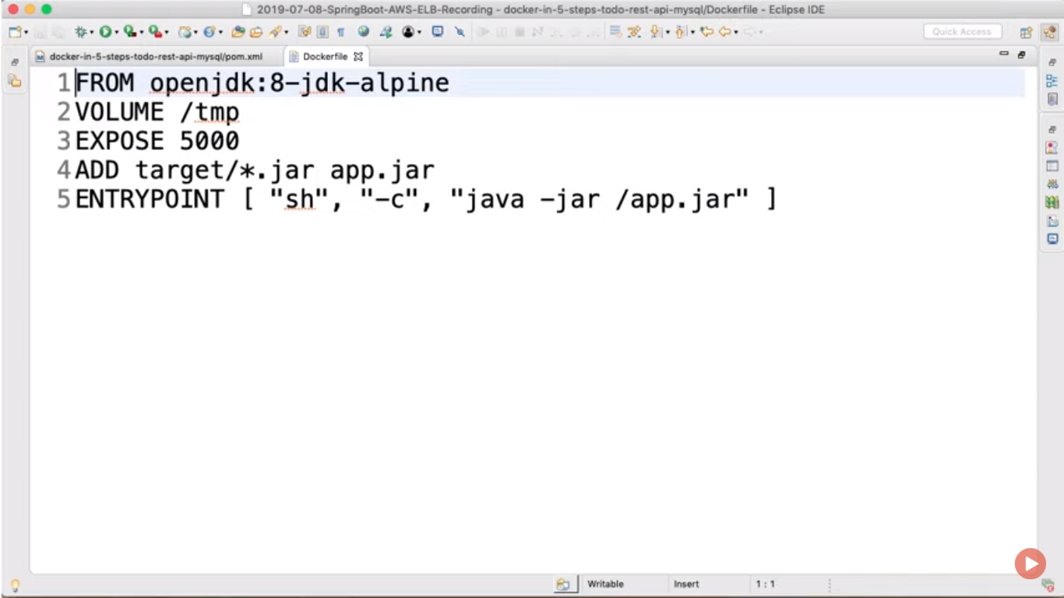

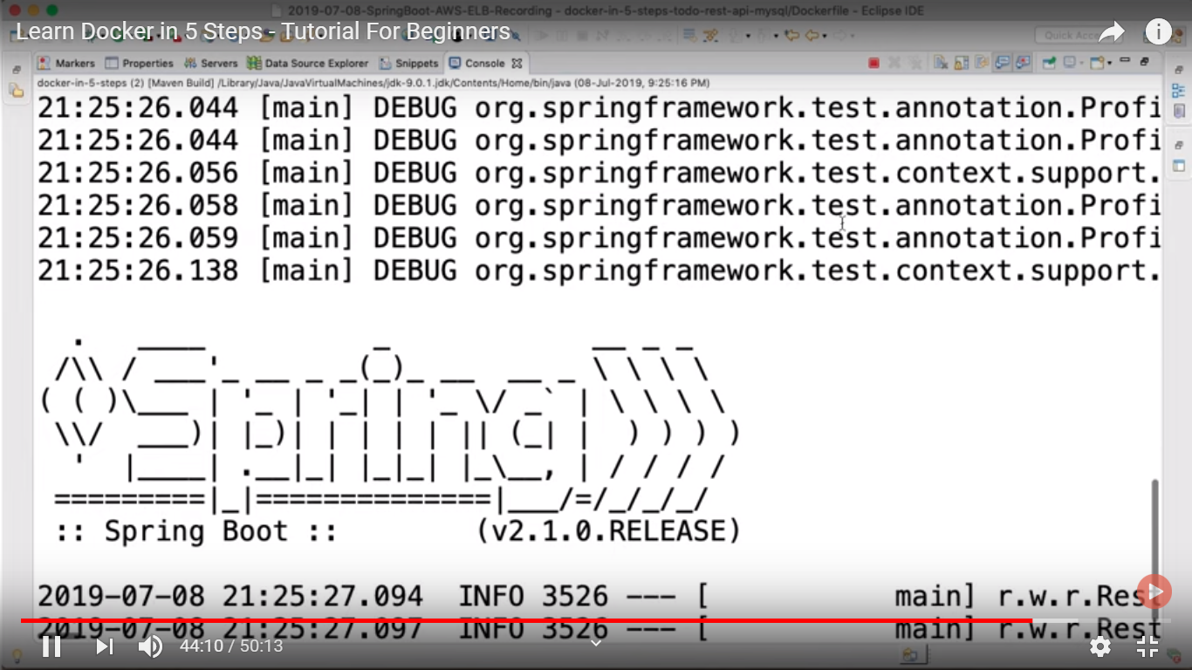

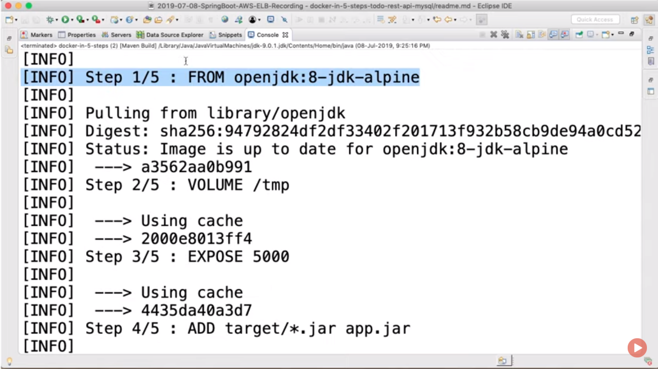

Build life cycle..

Name of repository:: or docker id in28min

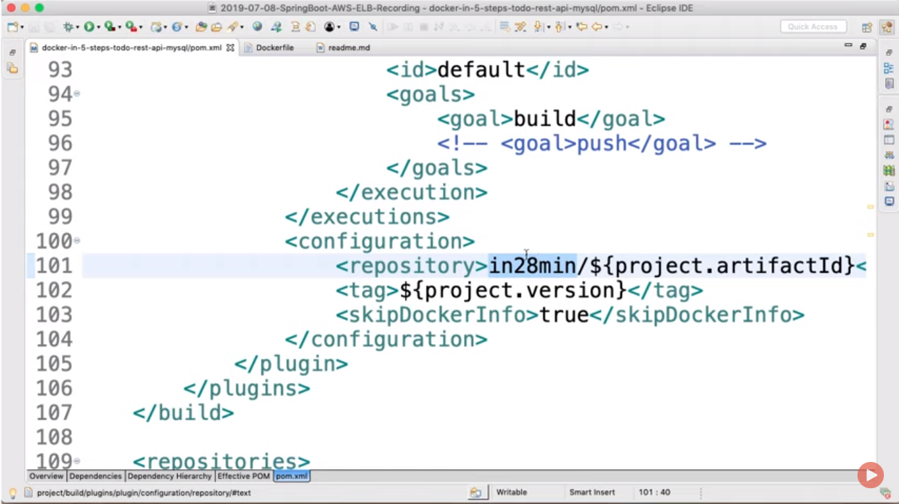

For docker push::  
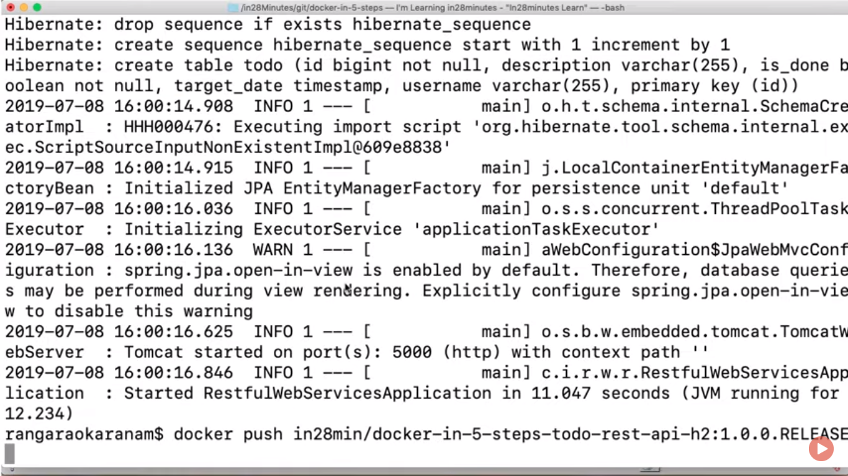

Docker file refreces for r&d

